IEEE Technical Committee on Variable Structure and Sliding Mode Control: April 2012 Report
TC Chair: Sarah Spurgeon s.k.spurgeon@kent.ac.uk
Since the previous report submitted in November 2011, the Variable Structure and Sliding Mode Control community has been involved with the following activities:-
- The TC has hosted the twelfth international workshop on variable structure systems which was held in Mumbai from 12th-14th Jan 2012. Both CSS and IES co-sponsored this very successful event. A total of 87 papers were presented at a mixture of oral and poster sessions. A range of plenary and semi-plenary lectures were also presented. The organising committee led by Professor Bandyopadhyay also organised an interesting social and cultural programme to complement the event. Four PhD students were awarded financial support via CSS to facilitate attendance.
- The TC is already involved in planning our next workshop which will be held in Nantes, France in 2014. The TC Chair will visit Nantes in June to confirm the local arrangements.
- A Journal Special Issue of the Franklin Institute entitled “Advances in Guidance and Control of Aerospace Vehicles using Sliding Mode Control and Observation Techniques” guest edited by Professor Yuri B. Shtessel, Dr. Christian H. Tournes and Professor Leonid Fridman was published in March 2012. This special issue contained a total of 18 papers.
- Papers have been submitted for a Special Issue of the IMA Journal of Mathematical Control and Information entitled ‘Lyapunov methods for Second Order Sliding Modes’ which will be guest edited by Professor Jaime Moreno.
- A Special Session on” Lyapunov Methods for Second Order Sliding Modes" organised by Leonid M. Fridman and Jaime A. Moreno was presented at the 50th IEEE Conference on Decision and Control and European Control Conference, Orlando, FL, USA in 2011. This contained a total of six papers.
- Members of the TC are involved in submissions to a Special Issue of Elsevier's Journal MATCOM on “Discontinuous Dynamical Systems: Theory and Numerical Methods”.
- TC members have organised a proposal for a CDC 2012 invited session in the area of sliding modes for hybrid and impulsive systems.
- The TC Chair presented an IEEE CSS Webinar entitled ‘On discontinuous observers : from basic properties to a robust fault detection and condition monitoring tool’ in January 2012.

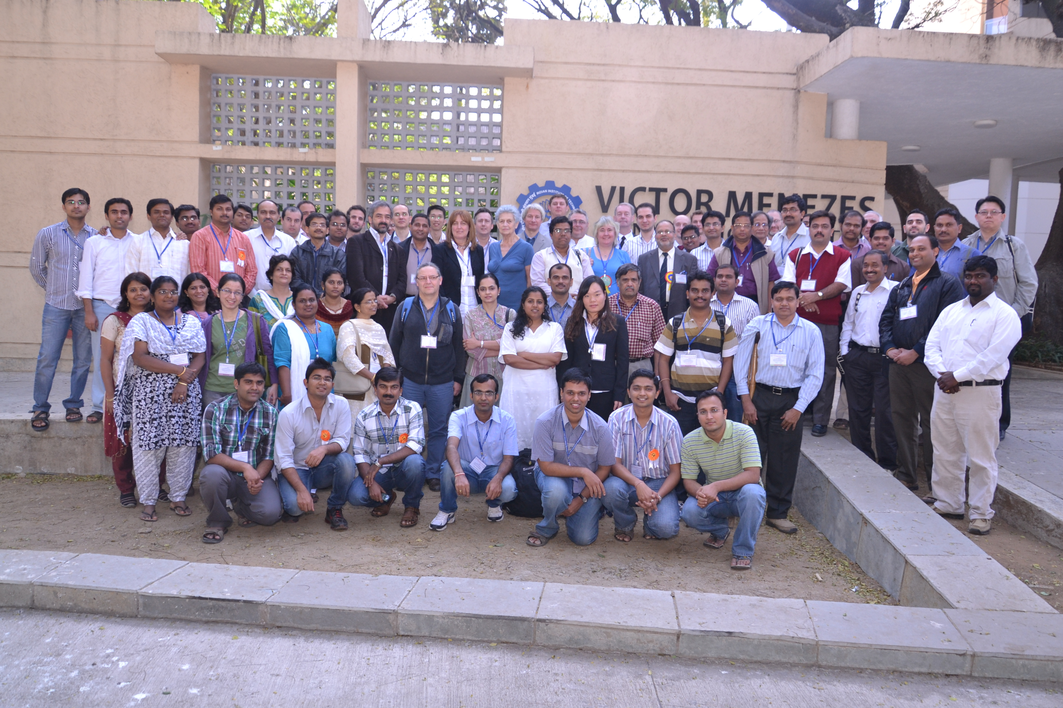
The VSSSMC Community at the Mumbai Workshop, January 2012.

