## IEEE CSS Award Nomination Instructions:

CSS will be using the system based on PaperPlaza for nominations for the following awards:

* Antonio Ruberti Young Researcher Prize
* Control Systems Technology Award
* Transition to Practice Award
* Excellence in Aerospace Control
* George S. Axelby Outstanding Paper Award
* TCST Outstanding Paper Award
* CSM Outstanding Paper Award
* TCNS Outstanding Paper Award

To make a nomination for an award, please follow the following steps:

Ensure both yourself, and anyone (up to 4 people) writing supporting letters, are registered users with PaperPlaza. In many cases, you will already have a PaperPlaza login and ID from using CSS conferences or publications. If so, please use your existing ID.

(i)              Download the relevant nomination form: (see the relevant pages within <http://ieeecss.org/awards> )

(ii)            Once you have completed the nomination form, please go to [awards.paperplaza.net](http://awards.paperplaza.net" \t "_blank)

(iii)          From the awards nomination page, select the ‘Submit a contribution to CSS Awards’ link

(iv)          From there, select the appropriate award/nomination by following the submit link in front of “{award name} – Nomination’”

(v)            Enter the title of your nomination, then select 1 from the dropdown for the number of proposers and enter your own pin as the proposer (that is nominator) and click on Next

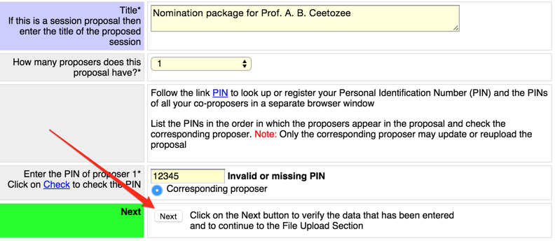

(vi)          Upload your filled out nomination form (note that awards do not need to satisfy pdf compliance checks). The only requirement is that the PDF must not be password protected. Note that the optional supporting information is not required and will not be considered in assessing the nomination.

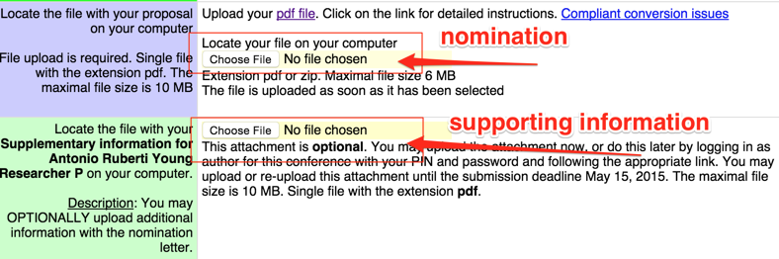

(vii)        Once you have uploaded the nomination form and supporting documentation. Go back to [awards.paperplaza.net](http://awards.paperplaza.net" \t "_blank) and follow the ‘Login’ link (below the “Submit a contribution to CSS Awards” that you previously selected).

In your workspace you will see a link ‘Author or proposer of submission’ that you select to "Send invitations and reminders for the proposal" where you can create the list of people you would like to invite to write reference letters and also send out invitations.

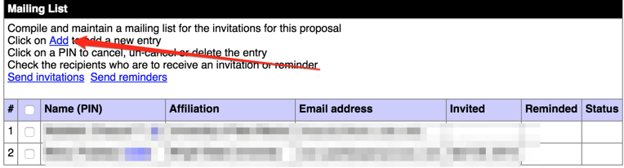

Invited people will receive an email from the server including a link to award site as well as code that invitees will need to use to link their “invited contribution” that is, reference letter, to your nomination package.

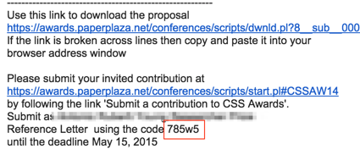

If they do not receive this code, you can find it in your workspace under nomination title.